Connect to AWS instance Via Putty
Host name : ec2-13-235-255-149.ap-south-1.compute.amazonaws.com
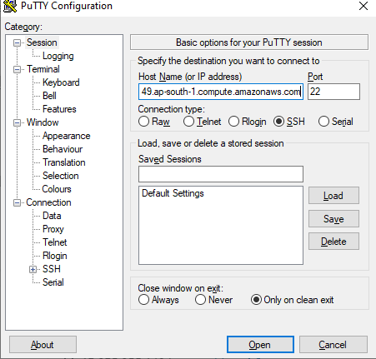

Save the attached .ppk file in your local drive
Navigate to SSH Auth and select the browse the locally saved .ppk file and open
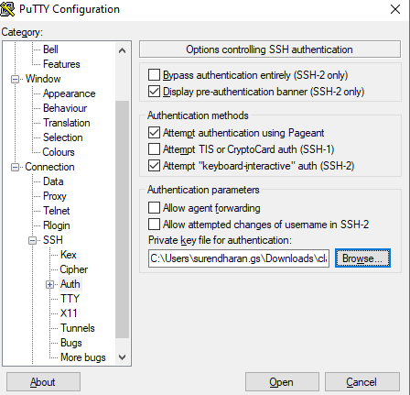

Login with user name as ubuntu

